Strict Interior Containment

Definition
# Source: AI Source: Provided by: [Data Path: Persons Table -> ID Column: 1, Name_En Column: Motasem Essam] -> From: [ChatGPT] on [7/25/2026]
Strict Interior Containment is a type of region containment in which one region lies entirely inside the interior of another region.
If $R_{1}$is strictly interiorly contained in $R_{2}$, then:
$$\boxed{R_{1}⊂int⁡\left(R_{2}\right)}$$
This means that every point of $R_{1}$is an interior point of $R_{2}$. No point of $R_{1}$lies on the boundary of $R_{2}$.
Equivalently:
$$\boxed{R_{1}∩∂R_{2}=∅}$$
when $R_{1}⊆R_{2}$.
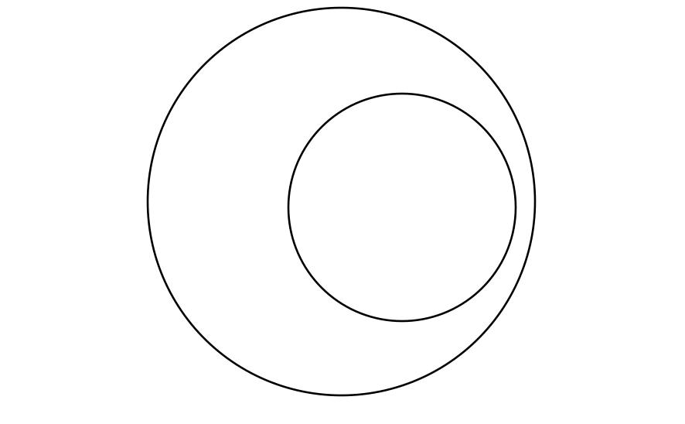
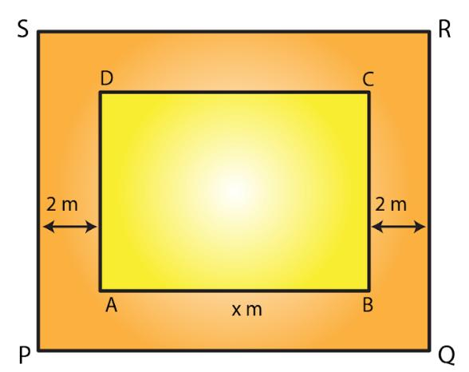
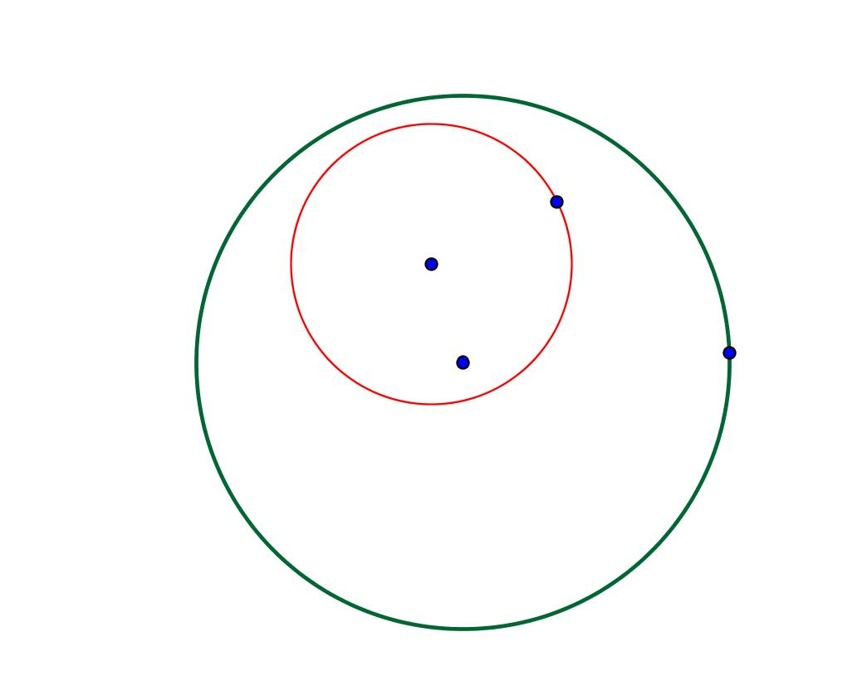

Purpose
# Source: AI Source: Provided by: [Data Path: Persons Table -> ID Column: 1, Name_En Column: Motasem Essam] -> From: [ChatGPT] on [7/25/2026]
Strict Interior Containment is used when it is important to establish that a region is completely separated from the boundary of the containing region.
It distinguishes a region that is safely inside another region from one that merely touches the outer boundary.
It is particularly useful in:
- geometry,
- topology,
- computational geometry,
- CAD,
- GIS,
- computer graphics,
- robotics,
- and spatial analysis.

Fundamental Concept
# Source: AI Source: Provided by: [Data Path: Persons Table -> ID Column: 1, Name_En Column: Motasem Essam] -> From: [ChatGPT] on [7/25/2026]
Every sufficiently well-defined region can be considered in terms of:
- Interior
- Boundary
- Exterior
For a region $R$:
$$\boxed{int⁡\left(R\right)}$$
represents its interior, while:
$$\boxed{∂R}$$
represents its boundary.
Strict interior containment requires:
$$\boxed{R_{1}⊂int⁡\left(R_{2}\right)}$$
Therefore, every point of $R_{1}$is inside $R_{2}$, with no point reaching $∂R_{2}$.

Mathematical Representation
# Source: AI Source: Provided by: [Data Path: Persons Table -> ID Column: 1, Name_En Column: Motasem Essam] -> From: [ChatGPT] on [7/25/2026]
The primary notation is:
$$\boxed{R_{1}⊂int⁡\left(R_{2}\right)}$$
A pointwise interpretation is:
$$\boxed{P∈R_{1}⇒P∈int⁡\left(R_{2}\right)}$$
Another equivalent condition, assuming $R_{1}⊆R_{2}$, is:
$$\boxed{R_{1}∩∂R_{2}=∅}$$
Thus:
$$\boxed{R_{1}⊆R_{2} \text{and} R_{1}∩∂R_{2}=∅}$$
describe the essential idea.

Fundamental Elements
# Source: AI Source: Provided by: [Data Path: Persons Table -> ID Column: 1, Name_En Column: Motasem Essam] -> From: [ChatGPT] on [7/25/2026]
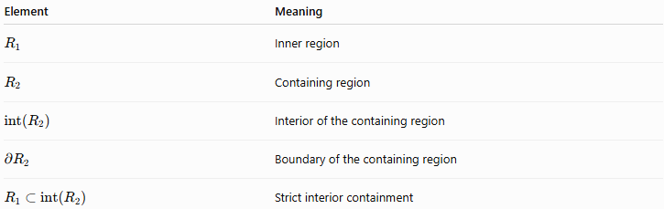
Element | Meaning
$$R_{1}$$ | Inner region
$$R_{2}$$ | Containing region
$$int⁡\left(R_{2}\right)$$ | Interior of the containing region
$$∂R_{2}$$ | Boundary of the containing region
$$R_{1}⊂int⁡\left(R_{2}\right)$$ | Strict interior containment

Example 1 – Smaller Disk Inside a Larger Disk
# Source: AI Source: Provided by: [Data Path: Persons Table -> ID Column: 1, Name_En Column: Motasem Essam] -> From: [ChatGPT] on [7/25/2026]
Consider:
$$R_{1}=\left\{\left(x , y\right)∣x^{2}+y^{2}≤4\right\}$$
and:
$$R_{2}=\left\{\left(x , y\right)∣x^{2}+y^{2}≤25\right\}$$
The inner disk has radius $2$, while the outer disk has radius $5$.
The interior of $R_{2}$is:
$$int⁡\left(R_{2}\right)=\left\{\left(x , y\right)∣x^{2}+y^{2}<25\right\}$$
Every point of $R_{1}$satisfies:
$$x^{2}+y^{2}≤4<25$$
Therefore:
$$\boxed{R_{1}⊂int⁡\left(R_{2}\right)}$$
The two circles do not touch.

Example 2 – Rectangle Inside a Larger Rectangle
# Source: AI Source: Provided by: [Data Path: Persons Table -> ID Column: 1, Name_En Column: Motasem Essam] -> From: [ChatGPT] on [7/25/2026]
Let:
$$R_{1}=\left\{\left(x , y\right) , ∣2≤x≤6 2≤y≤5\right\}$$
and:
$$R_{2}=\left\{\left(x , y\right) , ∣0≤x≤10 0≤y≤8\right\}$$
The inner rectangle has a positive distance from every side of the outer rectangle.
Therefore:
$$\boxed{R_{1}⊂int⁡\left(R_{2}\right)}$$
This is strict interior containment.

Example 3 – Circle Inside a Rectangle
# Source: AI Source: Provided by: [Data Path: Persons Table -> ID Column: 1, Name_En Column: Motasem Essam] -> From: [ChatGPT] on [7/25/2026]
Suppose a circular region is completely inside a rectangular region with a gap between the circle and every side of the rectangle.
Then:
$$\boxed{R_{\text{circle}}⊂int⁡\left(R_{\text{rectangle}}\right)}$$
The circle does not touch the rectangle boundary.

Strict Interior Containment vs Boundary-Touching Containment
# Source: AI Source: Provided by: [Data Path: Persons Table -> ID Column: 1, Name_En Column: Motasem Essam] -> From: [ChatGPT] on [7/25/2026]
This is the most important comparison.
Strict Interior Containment
$$\boxed{R_{1}⊂int⁡\left(R_{2}\right)}$$
Therefore:
$$\boxed{R_{1}∩∂R_{2}=∅}$$
Boundary-Touching Containment
$$\boxed{R_{1}⊊R_{2}}$$
and:
$$\boxed{∂R_{1}∩∂R_{2}≠∅}$$
Therefore:
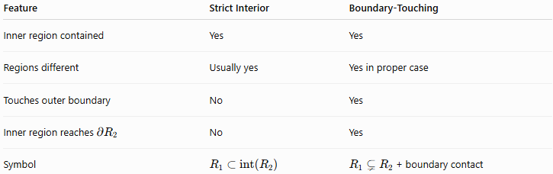
Feature | Strict Interior | Boundary-Touching
Inner region contained | Yes | Yes
Regions different | Usually yes | Yes in proper case
Touches outer boundary | No | Yes
Inner region reaches $∂R_{2}$ | No | Yes
Symbol | $$R_{1}⊂int⁡\left(R_{2}\right)$$ | $R_{1}⊊R_{2}$+ boundary contact

Strict Interior Containment vs Proper Containment
# Source: AI Source: Provided by: [Data Path: Persons Table -> ID Column: 1, Name_En Column: Motasem Essam] -> From: [ChatGPT] on [7/25/2026]
Strict interior containment is stronger than proper containment.
If:
$$R_{1}⊂int⁡\left(R_{2}\right)$$
then:
$$\boxed{R_{1}⊊R_{2}}$$
for nonempty regions under the usual geometric assumptions.
However, the reverse is not always true.
For example, a smaller circle internally tangent to a larger circle satisfies:
$$R_{1}⊊R_{2}$$
but:
$$R_{1}⊄int⁡\left(R_{2}\right)$$
because one point lies on the outer boundary.
Thus:
$$\boxed{\text{Strict Interior Containment}⇒\text{Proper Containment}}$$
but generally:
$$\boxed{\text{Proper Containment}⇏\text{Strict Interior Containment}}$$

Boundary Condition
# Source: AI Source: Provided by: [Data Path: Persons Table -> ID Column: 1, Name_En Column: Motasem Essam] -> From: [ChatGPT] on [7/25/2026]
The defining feature is the absence of boundary contact.
For strict interior containment:
$$\boxed{R_{1}∩∂R_{2}=∅}$$
This means there is no point $P$such that:
$$P∈R_{1}$$
and:
$$P∈∂R_{2}$$

Positive Separation
# Source: AI Source: Provided by: [Data Path: Persons Table -> ID Column: 1, Name_En Column: Motasem Essam] -> From: [ChatGPT] on [7/25/2026]
For many common closed, bounded geometric regions, strict interior containment produces a positive minimum distance between the inner region and the outer boundary:
$$\boxed{d\left(R_{1} , ∂R_{2}\right)>0}$$
where $d$represents the minimum distance between the two sets.
For example, if a disk of radius $2$is concentric with a disk of radius $5$, the minimum distance from the inner disk to the outer boundary is:
$$5-2=3$$
Therefore:
$$\boxed{d\left(R_{1} , ∂R_{2}\right)=3}$$
This positive separation is useful in engineering and computational applications.

Topological Interpretation
# Source: AI Source: Provided by: [Data Path: Persons Table -> ID Column: 1, Name_En Column: Motasem Essam] -> From: [ChatGPT] on [7/25/2026]
A point $P$is an interior point of $R_{2}$if there exists some positive radius $ε$such that a small neighborhood around $P$remains completely inside $R_{2}$.
In two dimensions:
$$\boxed{B\left(P , ε\right)⊆R_{2}}$$
for some:
$$ε>0$$
Strict interior containment requires this condition for every point of $R_{1}$.
Therefore:
$$\boxed{P∈R_{1}⇒P∈int⁡\left(R_{2}\right)}$$

Coordinate Geometry
# Source: AI Source: Provided by: [Data Path: Persons Table -> ID Column: 1, Name_En Column: Motasem Essam] -> From: [ChatGPT] on [7/25/2026]
Strict interior containment can often be verified using inequalities.
Circle
For:
$$R_{2}=\left\{\left(x , y\right)∣x^{2}+y^{2}≤25\right\}$$
its interior is:
$$int⁡\left(R_{2}\right)=\left\{\left(x , y\right)∣x^{2}+y^{2}<25\right\}$$
Therefore, to establish strict interior containment:
$$\boxed{P∈R_{1}⇒x_{P}^{2}+y_{P}^{2}<25}$$
for every point $P$in $R_{1}$.

Rectangle
# Source: AI Source: Provided by: [Data Path: Persons Table -> ID Column: 1, Name_En Column: Motasem Essam] -> From: [ChatGPT] on [7/25/2026]
For:
$$R_{2}=\left\{\left(x , y\right) , ∣0≤x≤10 0≤y≤8\right\}$$
the interior is:
$$int⁡\left(R_{2}\right)=\left\{\left(x , y\right) , ∣0<x<10 0<y<8\right\}$$
Thus:
$$\boxed{R_{1}⊂int⁡\left(R_{2}\right)}$$
requires every point of $R_{1}$to satisfy:
$$0<x<10$$
and:
$$0<y<8$$

Closed and Open Regions
# Source: AI Source: Provided by: [Data Path: Persons Table -> ID Column: 1, Name_En Column: Motasem Essam] -> From: [ChatGPT] on [7/25/2026]
The distinction between open and closed regions is important.
A closed disk:
$$x^{2}+y^{2}≤r^{2}$$
includes its boundary.
An open disk:
$$x^{2}+y^{2}<r^{2}$$
does not include its boundary.
The notation:
$$R_{1}⊂int⁡\left(R_{2}\right)$$
focuses on the interior of the containing region, regardless of whether $R_{2}$itself includes its boundary.

Properties

1. Implies Proper Containment
# Source: AI Source: Provided by: [Data Path: Persons Table -> ID Column: 1, Name_En Column: Motasem Essam] -> From: [ChatGPT] on [7/25/2026]
Under the usual nonempty-region assumptions:
$$\boxed{R_{1}⊂int⁡\left(R_{2}\right)⇒R_{1}⊊R_{2}}$$

2. No Boundary Contact
# Source: AI Source: Provided by: [Data Path: Persons Table -> ID Column: 1, Name_En Column: Motasem Essam] -> From: [ChatGPT] on [7/25/2026]
$$\boxed{R_{1}∩∂R_{2}=∅}$$

3. It Is Directional
# Source: AI Source: Provided by: [Data Path: Persons Table -> ID Column: 1, Name_En Column: Motasem Essam] -> From: [ChatGPT] on [7/25/2026]
If:
$$R_{1}⊂int⁡\left(R_{2}\right)$$
then generally:
$$R_{2}⊄int⁡\left(R_{1}\right)$$
The smaller region is the contained region.

4. It Is Transitive
# Source: AI Source: Provided by: [Data Path: Persons Table -> ID Column: 1, Name_En Column: Motasem Essam] -> From: [ChatGPT] on [7/25/2026]
Suppose:
$$R_{1}⊂int⁡\left(R_{2}\right)$$
and:
$$R_{2}⊂int⁡\left(R_{3}\right)$$
Under the standard geometric setting, this gives:
$$\boxed{R_{1}⊂int⁡\left(R_{3}\right)}$$
Thus strict interior containment behaves naturally as a nested interior relationship.

5. It Implies Overlap
# Source: AI Source: Provided by: [Data Path: Persons Table -> ID Column: 1, Name_En Column: Motasem Essam] -> From: [ChatGPT] on [7/25/2026]
Since:
$$R_{1}⊆R_{2}$$
we have:
$$\boxed{R_{1}∩R_{2}=R_{1}}$$
for the usual nonempty case.
Therefore, strictly contained regions are not disjoint.

Higher-Dimensional Regions
# Source: AI Source: Provided by: [Data Path: Persons Table -> ID Column: 1, Name_En Column: Motasem Essam] -> From: [ChatGPT] on [7/25/2026]
Strict interior containment is not limited to 2D.
Three Dimensions
For a solid $V_{1}$inside another solid $V_{2}$:
$$\boxed{V_{1}⊂int⁡\left(V_{2}\right)}$$
For example, a smaller solid sphere completely inside a larger solid sphere without touching its surface.

Region Inside a Plane
# Source: AI Source: Provided by: [Data Path: Persons Table -> ID Column: 1, Name_En Column: Motasem Essam] -> From: [ChatGPT] on [7/25/2026]
A planar region $R$can be contained in the interior of another planar region:
$$\boxed{R_{1}⊂int⁡\left(R_{2}\right)}$$
while both regions belong to the same plane.

Comparison with Other Region Relationships
# Source: AI Source: Provided by: [Data Path: Persons Table -> ID Column: 1, Name_En Column: Motasem Essam] -> From: [ChatGPT] on [7/25/2026]
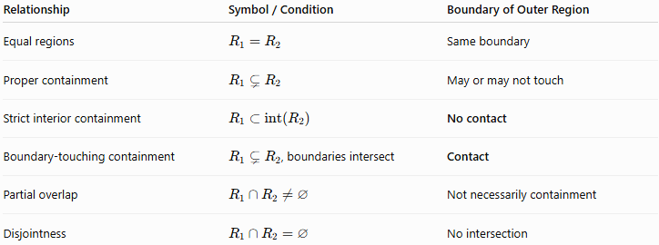
Relationship | Symbol / Condition | Boundary of Outer Region
Equal regions | $$R_{1}=R_{2}$$ | Same boundary
Proper containment | $$R_{1}⊊R_{2}$$ | May or may not touch
Strict interior containment | $$R_{1}⊂int⁡\left(R_{2}\right)$$ | No contact
Boundary-touching containment | $R_{1}⊊R_{2}$, boundaries intersect | Contact
Partial overlap | $$R_{1}∩R_{2}≠∅$$ | Not necessarily containment
Disjointness | $$R_{1}∩R_{2}=∅$$ | No intersection

Real-World Applications
# Source: AI Source: Provided by: [Data Path: Persons Table -> ID Column: 1, Name_En Column: Motasem Essam] -> From: [ChatGPT] on [7/25/2026]
Architecture
A room or structural component can be positioned completely inside a larger floor region with clearance from the walls.
Engineering
A component can be designed with a safety clearance inside a housing:
$$\boxed{\text{Component}⊂int⁡\left(\text{Housing}\right)}$$
CAD
Designers use interior containment to ensure that objects remain inside an enclosure without touching its boundary.
Robotics
A robot's operating region may need to remain strictly inside a permitted workspace, leaving a safety margin around the boundary.
Computer Graphics
An object can be completely inside a viewport or clipping region without touching its edge.
GIS
A geographic region may be required to remain entirely within another administrative or operational region without sharing its boundary.

Key Points
# Source: AI Source: Provided by: [Data Path: Persons Table -> ID Column: 1, Name_En Column: Motasem Essam] -> From: [ChatGPT] on [7/25/2026]
- Strict Interior Containment means one region lies entirely inside the interior of another.
- Its principal notation is:
$$\boxed{R_{1}⊂int⁡\left(R_{2}\right)}$$
- No point of $R_{1}$lies on the boundary of $R_{2}$:
$$\boxed{R_{1}∩∂R_{2}=∅}$$
- It is stronger than ordinary proper containment.
- A properly contained region may touch the outer boundary; a strictly interiorly contained region cannot.
- It normally provides a positive separation from the outer boundary for closed, bounded regions.
- It applies to both 2D and 3D geometric regions.
- Internal tangency is not strict interior containment because the regions share a boundary point.

Conclusion
# Source: AI Source: Provided by: [Data Path: Persons Table -> ID Column: 1, Name_En Column: Motasem Essam] -> From: [ChatGPT] on [7/25/2026]
Strict Interior Containment describes the strongest common form of nested region containment in which the entire inner region remains within the interior of the containing region:
$$\boxed{R_{1}⊂int⁡\left(R_{2}\right)}$$
The defining characteristic is:
$$\boxed{R_{1}∩∂R_{2}=∅}$$
Thus, unlike Boundary-Touching Containment, the inner region has no contact with the boundary of the outer region. This distinction is especially important when geometric clearance, safety margins, or strict spatial separation are required.

